DEVELOPMENTAL LANGUAGE LAB

Goal: to understand childhood language disorders and what causes them.

Who we are: Scientists, trained doctoral students, and Speech-Language Pathologists interested in learning how children understand language.

What we do: We conduct fun experiments that explore how children perceive, process, and produce speech and language!

CONTACT US
If you’re interested in participating
or would like more information!

CUNY Graduate Center
Speech, Language,
and Hearing Sciences
Room 7410
365 Fifth Ave
(btw. 34th and 35th)
New York, NY 10016
(212) 817-8813
E-mail: childlanguagelab.cuny@gmail.com

Visit us on Facebook!
Facebook.com/ChildLanguageLaboratory

Follow us on Twitter!
Twitter.com/@ChildLanguageGC

GETTING HERE:
- 1, 2, 3, A, C, E to 34th St.
- B, D, F, M, Q, N, R to 34th St.
- 6 to 33rd St.
- PATH to 33rd St.
Your Child’s Language

- Is your child developing language at the same pace as his or her friends?
- We will address your concerns and provide a free evaluation!

The City University of New York
The Graduate Center
Speech, Language, Hearing
Sciences

DETAILS

We provide an exceptional opportunity for you to know your child’s language, speech and hearing abilities

• Children must be 6-12 years old

• Spoken English must be the primary language used at home

• Participants receive up to $60 dollars ($15 per hour)

• Results of speech, language, and hearing tests will be available to you in a written report

Our studies have been approved by the Institutional Review Board of the Graduate Center of the City University of New York.
OUR QUESTIONS
How do children understand complex language?
What does tracking eye movements tell us about how children organize words and use language?

WHAT IS INVOLVED?
Hearing Screening
Standardized Language Tests
Computer Activities
PRIZES!

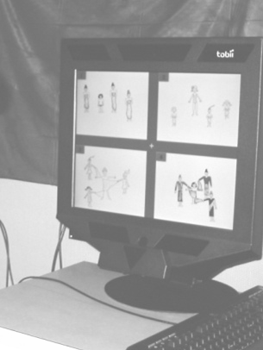

TYPICAL SESSION

4:00 Arrive and meet clinician in the waiting room, sign consent forms, and discuss testing procedures

4:10 Conduct hearing screening and administer language tests to the child in a private clinic room

5:00 Break for a snack with parent in the waiting room

5:10 Continue testing

6:00 Complete testing and receive compensation

Sessions are scheduled at participants’ convenience during the week or on weekends.

We are available to discuss any of your concerns or answer any questions you have about the testing.

